**Subject**: Data Quality Issues and Improvement Plan

**Dear John Doe**,

I hope this email finds you well. I am writing to address some concerning data quality issues that have come to our attention. Our recent review of the company's data has revealed inaccuracies, incompleteness, inconsistency, and other issues that are affecting the overall reliability and usefulness of our data.

Below is a summary table highlighting the major data quality issues we have identified in each data category:

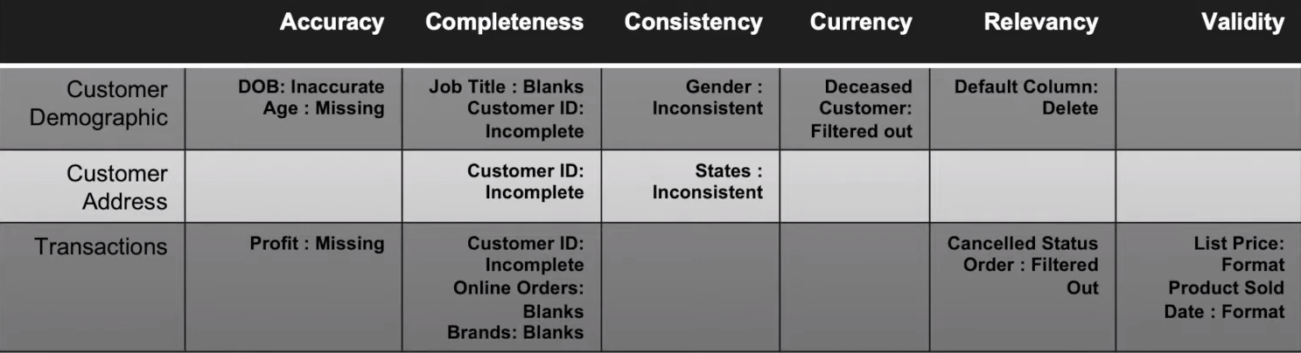

**CUSTOMER DEMOGRAPHIC**:

Date of Birth (DOB): Inaccurate

Age: Missing

Job Title: Blanks

Customer ID: Incomplete

Gender: Inconsistency

Deceased Customers: Filter Out

Default column: Delete

**CUSTOMER ADDRESS**:

Customer ID: Incomplete

States: Inconsistency

**TRANSACTIONS:**

Profit: Missing

Customer ID: Incomplete

Online Order: Blanks

Brand: Blanks

Cancelled Status order: Filter Out

List Price: Format

Product sold date: Format

To address these issues, I propose the following improvement plan:

Data Validation and Cleaning: We will conduct a thorough data validation process to identify and correct inaccurate, incomplete, and inconsistent entries in the database. This includes validating DOBs, completing missing information, and ensuring gender consistency.

Data Enrichment: To enhance our understanding of customers, we will work on enriching the customer demographic data by acquiring missing job titles and updating customer addresses.

Deceased Customer Handling: We will develop a mechanism to filter out and remove deceased customers from our database regularly.

Transaction Data Standardization: Our team will standardize the format of missing profit values, online orders, and brand information to ensure consistency and improve data reliability.

Data Currency and Relevancy: We will implement regular updates to keep the data current and relevant, removing outdated or irrelevant entries as necessary.

Improved Data Entry Guidelines: We will create and communicate clear data entry guidelines to ensure better data quality from the source.

Data Quality Monitoring: To prevent future data quality issues, we will establish a data quality monitoring system that regularly checks for data inconsistencies and alerts us of any potential problems.

I believe that by implementing these measures, we can significantly improve the accuracy, completeness, consistency, currency, relevancy, and validity of our data, ultimately leading to better decision-making and enhanced customer experiences.

I request your support and cooperation in carrying out these data quality improvements. If you have any suggestions or concerns, please feel free to share them with me. Let's work together to ensure that our data remains a reliable and valuable asset for the company.

Thank you for your attention to this matter.

Best regards,

Omkar Bulland

Data Analyst

KPMG